IMPORTANT
If you need a repair you can either:
TEXT:
ONLINE:
EMAIL:
PHONE:

YOUR DETAILS
BEST TEL:
EMAIL:
N.I. NUMBER:

And

…………………………………..

Tenancy Agreement
For letting unfurnished dwelling – house at

On an assured shorthold tenancy
Rent ………………… Per Calendar Month

- TENANCY AGREEMENT
  - THE PARTIES
This Short Assured Tenancy (‘the tenancy’) is between

“Your company name” (the landlord)

Whose address is:

And

………………………………………………………………

(the tenant)
And is on the following terms and conditions:

  - THE ACCOMMODATION. The tenancy is of the following accommodation:

………………………………………………………………………………..

  - During the period of the tenancy the tenant is entitled to make use, in the accommodation, of the fixtures, fittings, furniture and furnishings specified in the inventory checked and signed by the landlord and the tenant
  - PERIOD OF TENANCY. The tenancy starts ……………………………….. including the whole of the day. This is regardless of the date that this tenancy agreement is signed by the landlord and the tenant. The initial period of the tenancy is for six months from the start of this tenancy. Unless the landlord or the tenant has brought the tenancy to an end at, or before, the end of the initial period, the tenancy will continue thereafter on a month to month basis until terminated in terms of paragraphs 5.1 to 5.4 of this agreement.

  - RENT. The rent is £……………. per month payable in advance on the ………day of the month.
The rent should be paid in the following way:
Standing Order
  - RENT INCREASES. The landlord is entitled to increase the rent as at the anniversary of the entry date each anniversary thereafter save that the landlord shall not be entitles to increase the rent during the initial period of the tenancy. At least two months’ written notice any rent increase will be given. The tenant will be entitled, on receipt of such notice, to terminate the tenancy as provided for in paragraph 5.1 of this tenancy agreement, before the increase takes effect.
  - BILLS. The tenant is solely liable for the payment of all charges for the supply of utilities (such as electricity, gas and telephone), council tax, water and sewerage charges in respect of the accommodation. The tenant will take all reasonable steps to transfer such utilities into his/her own name and will advise the local authority’s council tax department of the ate of the commencement of the tenancy. The tenant must not seek, or allow, disconnection of any utility, or alter the identity of the supplier without the written permission of the landlord.
  - BREACH. If the tenant is in material breach of any term or condition of this tenancy agreement, the landlord is entitled to terminate the tenancy, by means of a notice to quit, and take steps to recover possession of the tenancy. Material breach includes non-payment of any amount of the rent or service charges (regardless of the reason for non-payment) for a period of 14 days or more from the date that the rent becomes due in terms of this tenancy agreement. Furthermore, if the tenant is in breach of any term or condition of this tenancy agreement, whether the breach is material or not, (and whether or not the tenancy is terminated as a result), the tenant is liable to the landlord for any losses resulting from the breach.
  - JOINT AND SEVERAL LIABILITY. Joint tenants are jointly and severally liable for all obligations of the tenancy.
  - SERVICE OF NOTICE. Any notices or documents may be served on or sent to the landlord at the address in paragraph 1.1 above. The landlord shall be entitled to send, serve or deliver any notice or document to the tenant at the accommodation.
  - PERMISSIONS. Whenever in this agreement the permission of the landlord is required, that permission will not be unreasonably withheld.

2. USE OF THE ACCOMMODATION
2.1 ONLY OR PRINCIPAL HOME. The tenant must occupy the accommodation as his/her only principal home and for no other purpose. The tenant must not allow the accommodation to be shared with any other person whatsoever, whether in return for payment or otherwise, without the written permission of the landlord.
2.2 ASSIGNATION ETC. The tenant is not entitled to assign the tenancy, sub-let any part of the accommodation, take lodgers or other paying guests or otherwise part with possession of any part of the accommodation without the written permission of the landlord.
2.3 TAKE REASONABLE CARE. The tenant, and those living with or visiting the tenant, must take reasonable care not to cause or allow damage to be caused to the accommodation, decoration, fixtures, fittings, furnishings, the common parts and property of neighbours. The tenant will keep the accommodation reasonably well heated and ventilated.
2.4 SECURITY. The tenant will take all reasonable steps to safeguard the accommodation. In particular, the tenant will lock the external door at night and lock window locks and turn on any intruder alarm, whenever the accommodation is unoccupied. The tenant will inform the landlord in advance if the accommodation is to be left unoccupied for more than two weeks.
2.5 BUSINESS USE. The tenant must not run any kind of business from the accommodation without the written permission of the landlord.
2.6 NO ILLEGAL OR IMMORAL USE. The accommodation must not be used for illegal or immoral purposes.
2.7 PETS. The tenant must not keep any kind of pet in the accommodation without the written permission of the landlord.
2.8 COMMON PARTS TIDY. The tenant must take his/her turn in keeping the common parts, (including any common close, stair, garden, back green or other communal area) clean and tidy. The tenant must not use any of the common parts for the storage or deposit of their property without the written permission of the landlord.
2.9 REFUSE. The tenant must put all the household rubbish for collection in the bin store or other proper place allowed for it. If no such place exists, rubbish must not be placed anywhere in the common parts and should be put out for collection only on the day designated for collection.

3. RESPECT FOR OTHERS
3.1 ANTISOCIAL BEHAVIOUR. The tenant, those living with the tenant and visitors to the accommodation must not harass, or act in an antisocial manner to, any person in the neighbourhood on any ground, including that person’s racial or ethnic origin, colour, religion, sex, gender, sexual orientation, age, disability or other status.
3.2 Antisocial means causing, or likely to cause, alarm, distress, nuisance or annoyance to any person or causing damage to anyone’s property. Harassment of a person includes causing the person alarm or distress.
4. REPAIRS AND MAINTENANCE
4.1 Landlord’s Responsibilities and Rights
4.1.1 THE REPAIRING STANDARD. The landlord will ensure that the accommodation meets the ‘repairing standard’ at the start of the tenancy and at all times during the tenancy. The repairing standard is defined by section 13 of the Housing (Scotland) Act 2006. The main provisions of the repairing standard are as follows:
- The house is wind and watertight and in all other respects reasonably fir for human habitation. Regard is to be had to the extent to which the house by reason of disrepair or sanitary defects falls short of the provision of any build regulations.
- The installations in the house for the supply of water, gas and electricity and for sanitation, space heating and heating water are in a reasonable state of repair and in proper working order. Installations include installations outside the accommodation which serve the accommodation and which the owner is legally liable to maintain whether alone or in common with others
- Any fixtures, fittings and appliances provided by the landlord under the tenancy agreement are in a reasonable state of repair and in proper working order.
- Any furnishings provided by the landlord under the tenancy are capable of being used safely for the purpose for which they are designed.
- The accommodation has satisfactory provision for detecting fires and for giving warning in the event of fire or suspected fire. Regard is to be had to the building regulations and any guidance issued by the Scottish Ministers in deciding whether this repairing standard has been met.
- The structure and exterior of the house (including drains, gutters and external pipes) are in a reasonable state of repair and proper working order. If the accommodation is a flat forming part of a larger premise, this part of the repairing Standard includes reference to those parts of the premises which the landlord is legally responsible for maintaining whether alone or in common with others. However, the landlord is not obliged to carry out work unless any part of the premises, or anything in it, which the tenant is entitled to use, is adversely affected by the disrepair or failure to keep in working order. Regard is to be had to the age, character and the prospective life of the accommodation and the locality in determining whether this part o the repairing standard has been met.
4.1.2 The landlord will inspect the accommodation before the start of the tenancy to identify any work necessary to ensure that the house meets the repairing standard and will notify the tenant of that work. During the course of the tenancy, the landlord’s duty to meet the repairing standard will only apply if the tenant notifies the landlord of the work that requires to be done or if the landlord is to meet the repairing standard will be completed within a reasonable times of the landlord being notified of the need for the work, or the landlord otherwise becoming aware of the need for work to be done.
If you believe that the landlord has failed to ensure that the house meets the Repairing Standard at all times during the tenancy, you have the right to apply to the Private Rented Housing Panel (PRHP). The PRHP may reject the application; consider whether the case can be resolved by us (the Tenant and Landlord) ourselves (for example, by agreeing to mediation); or refer your application to a Private Rented Housing Committee (PRHC) for consideration. The PRHC has power to require a Landlord to carry out work necessary to meet the Repairing Standard.
4.1.3 EXCEPTIONS TO THE LANDLORD’S REAPIRING DUTY. The landlord’s repairing duty specified above does not oblige the landlord to:
- Do work for which the tenant is liable by virtue of his duty to use the house in a proper manner (even if the landlord has undertaken to do the work.) Therefore, the landlord is not responsible for repair or maintenance cause through fault of the tenant, anyone in the household or visitors. If the landlord chooses to repair such damage, the tenant is liable for the cost. This paragraph does not apply to fair wear and tear
- Rebuild or reinstate the accommodation destroyed or damaged by a storm, flood or other inevitable accident or
- Repair or maintain anything which the tenant is entitled to remove from the house.
The landlord is not to be treated as having failed to comply with his repairing duties specified above if the reason why the work was not done was because the landlord lacked the necessary rights (such as rights of access) to carry out the work despite having taken reasonable steps to get those rights.
4.1.4 GAS SAFETY. The landlord will inspect the gas installations annually and will provide the tenant with full instructions on the operation of gas appliances and the action to be taken in the event of any malfunction of gas appliances or installations.
4.1.5 FIRE SAFETY. The landlord will provide the tenant with instructions on the action to be taken in the event of fire in the accommodation.
4.1.6 RIGHT OF ENTRY. The landlord has the right to enter the accommodation for inspection or to carry out repairs or maintenance to the accommodation or the utilities serving it, at reasonable times during the day on 24 hours’ written notice, if the tenant does not allow entry, the landlord has the right to make forcible entry for these purposes providing that reasonable written notice is given of the landlord’s intention to do so. In an emergency affecting the accommodation or adjoining property, the landlord has the right to make forcible entry to the accommodation without notice. In this paragraph, ‘landlord’ includes those authorised by him.
4.1.7 COMMON PARTS. The landlord will, in conjunction with other co-owners, take reasonable steps to keep the common parts which the tenant is entitled to use (such as the close, common stair, back green, storage areas) in repair and fit for use by the tenant.
4.2 TENANT’S RESPONSIBILITIES AND RIGHTS
4.2.1 DUTY TO REPORT. The tenant must report any damage to the accommodation, or the common parts, pr the need for repairs or maintenance, as soon as reasonably practicable. The tenant must immediately report to the landlord any emergencies affecting the accommodation including interruption to the supply of water, gas and electricity.
4.2.2 REASONABLE CARE AND MAINTENANCE. The tenant is responsible for taking reasonable care of the accommodation. This includes carrying out minor routine maintenance, replacement of consumables and internal decoration. This includes, but is not limited to:
- Replacement of light bulbs, batteries, fuses, filters etc. In addition, the tenant is responsible for the replacement of lost and broken keys. The tenant must keep the accommodation in a reasonable state of cleanliness and decoration. However, the tenant is not responsible for carrying out repairs due to fair wear and tear.
4.2.3 REPAIR DUE TO TENANT FAULT. The tenant is responsible for repair (including replacement) of damage to the accommodation, or loss of any of the fixtures, fittings and items in the inventory, caused through the fault of the tenant, anyone in the household or visitors.
4.2.4 COLD WEATHER. If the accommodation has central heating, the central heating must be kept in operation at no less than frost protection when the external temperature is at or below freezing point or it is reasonably likely to fall to, or below that level.
4.2.5 ALTERATIONS. The tenant is not entitled to:
- Alter, improve or enlarge accommodation
- Add new fixtures or fittings to the accommodation
- Install external satellite aerials or dishes
- Erect any type of sign, flag or advertisement visible from outside the accommodation
- Put up a shed, garage or other structure
- Decorate the outside of the accommodation
- Change any of the locks in the accommodation or add new locks with the written permission of the landlord
However, the tenant has the right under certain conditions (under section 52 and 53 of the Housing (Scotland) Act 2006) to carry out adaptations to the house in connection with disability needs or in connection with certain energy efficient works.
4.2.6 If the landlord fails to perform his repairing responsibilities specified above, the tenant may make an application to the Private Rented Housing Panel.
5. ENDING THE TENANCY
The tenancy may be ended in any one of the four following ways. If the tenant fails to remove at the end of the tenancy, the landlord requires a court order to recover possession.
5.1 By written notice to quit from either the landlord or the tenant, to the other, terminating the tenancy on at least 28 days’ notice. The notice to quit may be served by the landlord for one or more of the following reasons:
- To prevent tacit relocation
- In response to a material breach of this tenancy agreement (as defined in paragraph 1.9 above)
- If any of the grounds contained in section 5 to the Housing (Scotland) Act 1988 are satisfied
Neither party is entitled to give notice to quit which would have effect before the expiry of the initial period (as defined by paragraph 1.4) except in the case of material breach of the tenant by the other party, or if any of the grounds contained in schedule 5 to the Housing (Scotland) Act 1988 are satisfied.
5.2 By written agreement between the parties at any time
5.3 By obtaining an order from the court for recovery of possession in accordance with Part II of the Housing (Scotland) Act 1988.
5.4 On the death of a tenant (or all of the joint tenants), the tenancy terminates automatically.
5.5 SUCCESSION TO THE TENANCY
On the death of the tenant, the spouse (including a person living with the tenant as husband or wife) or civil partner of the tenant who as living in accommodation as his or her only principal home may be entitled to succeed to the tenancy in terms of section 31 of the Housing (Scotland) Act 1988.
5.6 RESPONSIBILITIES OF THE TENANT BEFORE MOVING OUT
Before moving out of the accommodation, the tenant must do the following:
- Leave it in a clean and tidy condition and in good decorative order
- Remove all property not belonging to the landlord
- Make sure any lodgers, sub-tenants and anyone else living in the accommodation leaves at the same time.
- Allow the landlord and his/her agents access to the accommodation, at reasonable times , to show round new tenants or prospective purchasers
- Return the keys to the landlord
- Remove any fixtures and fittings installed without the landlord’s written permission and put right any damage caused.
- Do the repairs the tenant is obliged to do.
- Replace any fixtures, fittings or furnishings in the accommodation which have become lost.
- Give the landlord a forwarding address

6. COMPLETION OF AGREEMENT
IMPORTANT NOTICE TO THE PROSPECTIVE TENANT
By signing this agreement below, you are making the following declarations and also entering into a legally binding agreement. You should only sign this agreement if the declarations are true, you have read and understood the terms of this tenancy agreement and you want to enter in this tenancy agreement. If you have any doubt about the meaning of anything in this agreement, you should obtain independent advice before signing this agreement.

6.1 DECLARATIONS BY TENANT
The signature of the tenant below confirms the following:
- That the tenant has not knowingly or carelessly given false or materially misleading information to the landlord in connection with the obtaining of this tenancy.
- That the tenant made a full and true disclosure of all information sought by the landlord in connection with the grant of this tenancy
- That prior to signing this agreement, the tenant received a notice (the AT5) under section 32 (2) of the Housing (Scotland) Act 1988 notifying the tenant this tenancy is a Short Assured Tenancy.
- That the tenant has confirmed the existence of a fire blanket in the kitchen, confirmed the existence and tested the mains wired smoke alarm(s) and carbon monoxide alarm and viewed the results of the electrical test on the installations and are satisfied that the mains wired smoke alarm(s), carbon monoxide alarm, fire blanket and electrical installations are in working order.

6.2 PARTIES AGREEMENT. The signatures of the tenant and landlord below acknowledge that the parties have read and understood this agreement and agree to the tenancy of the accommodation on the terms and conditions contained in this Short Assured Tenancy Agreement.
SIGNED FOR AND ON BEHALF OF (Your company name)
Name: ……………………………………………………………………………………………………………………………………
Signature: ………………………………………………………………………………………………………………………………
Date of signature: ………………………………………………………………………………………………………………….
Name of Witness: ………………………………………………………………………………………………………………….
Signature: ………………………………………………………………………………………………………………………………
Date of Signature: ………………………………………………………………………………………………………………….
Address of Witness: ……………………………………………………………………………………………………………….
……………………………………………………………………………………………………………………………………………….
……………………………………………………………………………………………………………………………………………….
SIGNED BY THE TENANT
Name: …………………………………………………………………………………....................................................
Signature: ………………………………………………………………………………………………………………………………
Date of Signature: ………………………………………………………………………………………………………………….
Name of Witness: ………………………………………………………………………………………………………………….
Signature: ………………………………………………………………………………………………………………………………
Date of Signature: ………………………………………………………………………………………………………………….
Address of Witness: ……………………………………………………………………………………………………………….
……………………………………………………………………………………………………………………………………………….
……………………………………………………………………………………………………………………………………………….
FORM AT5: FOR USE ONLY BY A LANDLORD
ASSURED TENANCIES AT5
HOUSING (SCOTLAND) ACT 1988
NOTICE UNDER SECTION 32 TO BE
SERVED ON A PROSPECTIVE TENANT
OF A SHORT ASSURED TENANCY
IMPORTANT: INFORMATION FOR PROSPECTIVE TENANT(S)
This notice informs you as prospective tenant(s) that the tenancy being offered by the prospective landlord(s) is a short assured tenancy under Section 32 of the Housing (Scotland) Act 1988.
Please read this notice carefully.
Part 1 TO ……………………………………
(name of prospective tenant(s))

NOTE 1 TO PROSPECTIVE TENANT.

TO BE VALID THIS NOTICE MUST BE SERVED BEFORE THE CREATION OF A TENANCY AGREEMENT. A SHORT ASSURED TENANCY WILL NOT EXIST IF A VALID NOTICE HAS NOT BEEN SERVED.

Part 2 I your prospective landlord
(Your company name)

(name of landlord(s))

of (Your company address)
(address and telephone number of landlord(s))

give notice that the tenancy being offered to you of the
house
…………………………………………………………………………………………
(address of house)

to which this notice relates is to be a short assured tenancy in terms of Section 32 of the Housing (Scotland) Act 1988.

Signed ...............................................................……………………...
(landlord(s) or landlord's agent)

Date ...........................…..................................………………………

Signed ...............................................................……………………...
(tenants signature)

Date ...........................…..................................………………………
Time: ........................................................

NOTE 2 TO PROSPECTIVE TENANT.

A SHORT ASSURED TENANCY IS A SPECIAL FORM OF TENANCY. UNLESS IT FOLLOWS IMMEDIATELY AFTER ANOTHER SHORT ASSURED TENANCY OF THE SAME HOUSE, (WITH THE SAME TENANT) IT MUST BE FOR NOT LESS THAN 6 MONTHS.

NOTE 3 TO PROSPECTIVE TENANT.

A LANDLORD OF A SHORT ASSURED TENANCY HAS SPECIAL RIGHTS TO REPOSSESS THE HOUSE. IF THE LANDLORD TERMINATES THE TENANCY BY ISSUING A VALID NOTICE TO QUIT AND GIVES THE TENANT AT LEAST 2 MONTHS NOTICE (OR A LONGER PERIOD IF THE TENANCY AGREEMENT PROVIDES) OF HIS INTENTION TO REPOSSESS THE HOUSE THE COURT MUST GRANT THE LANDLORD AN ORDER ALLOWING HIM TO EVICT THE TENANT IF HE APPLIES FOR ONE AT THE END OF THE TENANCY PERIOD SET OUT IN THE TENANCY AGREEMENT.

Part 3. Address and telephone number of agents if appropriate:
of landlord(s) agent of Tenants(s) agent
(Your company name)
……………………………………………
(Your company address)

……………………………………………
……………………………………………
……………………………………………

NOTE 4 TO PROSPECTIVE TENANT.

A TENANT OF A SHORT ASSURED TENANCY HAS A SPECIAL RIGHT TO APPLY TO A RENT ASSESSMENT COMMITTEE FOR A RENT DETERMINATION FOR THE TENANCY.

NOTE 5 TO PROSPECTIVE TENANT.

IF YOU AGREE TO TAKE UP THE TENANCY AFTER YOUR LANDLORD HAS SERVED THIS NOTICE ON YOU YOUR TENANCY WILL BE A SHORT ASSURED TENANCY. YOU SHOULD KEEP THIS NOTICE IN A SAFE PLACE ALONG WITH THE WRITTEN DOCUMENT SETTING OUT THE TERMS OF TENANCY WHICH YOUR LANDLORD MUST PROVIDE UNDER SECTION 30 OF THE HOUSING (SCOTLAND) ACT 1988 ONCE THE TERMS ARE AGREED.

NOTE 6 TO PROSPECTIVE TENANT.

IF YOU REQUIRE FURTHER GUIDANCE ON ASSURED AND SHORT ASSURED TENANCIES, CONSULT A SOLICITOR OR ANY ORGANISATION WHICH GIVES ADVICE ON HOUSING MATTERS.
SPECIAL NOTES FOR EXISTING TENANTS
1. If you already have a regulated tenancy, other than a short tenancy, should you give it up and take a new tenancy in the same house or another house owned by the same landlord, that tenancy cannot be an assured tenancy or a short assured tenancy. Your tenancy will continue to be a regulated tenancy.
2. If you have a short tenancy under the Tenant's Rights etc (Scotland) Act 1980 of the Rent (Scotland) Act 1984 your landlord can offer you an assured tenancy or short assured tenancy of the same or another house on the expiry of your existing tenancy.
3. If you are an existing tenant and are uncertain about accepting the proposed short assured tenancy you are strongly advised to consult a solicitor or any organisation on which gives advice on housing matters.

ASSURED TENANCIES

HOUSING (SCOTLAND) ACT 1988

NOTES FOR LANDLORDS TO BE READ WITH NOTICE AT5

THESE NOTES ARE FOR GUIDANCE ONLY AND ARE NOT A DEFINITIVE

INTERPRETATION OF THE LAW
__________________________________________________________________________________________

WHEN TO USE THIS NOTICE

1 . You should use this notice only when you wish to inform a prospective tenant or tenants that the tenancy being offered by you is a short assured tenancy under Section 32 of the Housing (Scotland) Act 1988.
2. You must serve the notice on the prospective tenant or tenants before the creation of any tenancy agreement. If it is not served before the creation of the tenancy agreement the tenancy will not be a short assured tenancy.
__________________________________________________________________________________
ABOUT SHORT ASSURED TENANCIES
3. A short assured tenancy is a special form of assured tenancy which in the first instance must be for not less than 6 months. It gives you special rights to repossess the house (see paragraph 4) and special rights for tenants to apply to a Rent Assessment Committee for a rent determination (see paragraphs 5 and 6).

Repossession of the Property

- As landlord, if you obtain a possession order from the Sheriff, you may repossess the house you are letting on the short assured tenancy. Before applying for a possession order you must:

4.1 Issue a valid Notice to Quit to terminate the tenancy at its expiry date, and not offer your tenant another tenancy:

4.2 Give your tenant notice of your intention to apply for the order. The notice must be for at least 2 months unless your tenancy agreement provides for a longer period. If you fulfil these 2 conditions the Sheriff must grant you the order.

Rent
5. Unless a rent for the tenancy has already been determined by a Rent Assessment Committee, a tenant of a short assured tenancy has a right to seek a rent determination from a Rent Assessment Committee at any time during the tenancy. On receiving an application, the Committee will consider if it is appropriate to determine a market rent.
6. The Rent Assessment Committee will make a rent determination only if it considers there is a sufficient number of similar houses in the locality let on assured tenancies and the rent payable for the tenancy is significantly higher than the landlord might reasonably expect to charge having regard to rent levels for those tenancies. A rent determination made by the Committee will be the maximum payable for the tenancy from the date specified.
__________________________________________________________________________________

HOW TO USE THIS NOTICE

7. Before you and your prospective tenant make a binding agreement to let a house, you should complete Parts 1, 2 and 3 of the Notice. The Notice should then be given or sent to the prospective tenant or tenants. The tenancy will be a short assured tenancy as long as you have fulfilled all your requirements. The tenant should keep the Notice with the written document setting out the terms of the tenancy which have been agreed, and which must be provided by a landlord under Section 30 of the Housing (Scotland) Act 1988. You are also advised to keep a copy of Notice AT5 for your own records.
__________________________________________________________________________________

FURTHER GUIDANCE

8. If you are uncertain about the question of tenancy status or uncertain about how to complete this Notice, you should consult a solicitor or any organisation which gives advice on housing matters.
9. Further guidance on assured and short tenancies is available in "Assured Tenancies in Scotland-A Guide for Landlords and Tenants". Copies can be obtained from any office of the Rent Assessment Panel, Citizens Advice Bureau, Housing Advisory Centre or from any office of the Rent Registration Service.
__________________________________________________________________________________
TO WHOM IT MAY CONCERN:
I hereby give my authority to allow anyone who is involved with my housing benefit application or ongoing housing benefit payments to fully disclose anything in connection with my housing benefit to any representative of (Your company name).
(Your company name) have kindly given me this tenancy at below market value rent in order for me to secure and retain this tenancy. I also have trouble managing my own finances and I would be tempted to spend the first rent cheque on other things than my rent. Therefore I request my rent is paid directly to my landlord:
Account Name:
Account Number:
Sort Code:

………………………………………….. …………………………………………
Signature Date

…………………………………………
PRINT NAME
VULNERABILITY QUESTIONNAIRE
Do you have any learning disabilities? If yes please specify below:
Do you have any medical conditions that is likely to impair their ability to manage your own affairs on a day to day basis? If yes please specify below:
Do you have any literacy problems such as dyslexia? If yes please specify below:
Do you have trouble with speaking English? If yes please specify below:
Do you have or have you had an addiction to drugs alcohol or gambling in the last 6 months? If yes please specify below:
Do you have or have you had severe debt problems and are you in contact with any debt counsellors in the last 6 months? If yes please specify below:

Are you unable to manage your tenancy without support? Yes / No
Are you able to open a bank account? Yes / No
The answers given above are truthful and I give my authorisation for (Your company name) to discuss what you have stated above with whoever we deem suitable.

……………………........... ……………………………. .……………………….
Signature Print Name Date
STANDING ORDER SET UP
PAYER:
Name:
Branch:
Branch Address:
A/C Number:
Sort Code:
PAYEE:
Name:
Branch:
A/C Number:
Sort Code:

PAYMENT DETAILS:
Amount:
First Transfer Date:
Repeat (weekly/monthly):
Reference:
Last Transfer Date: | To be notified in writing

Please could you set up the above standing order on my behalf as soon as possible, to ensure that the first transfer payment is paid on time.

_____________________________________ _____________________
Signature Date
_____________________________________
Print Name

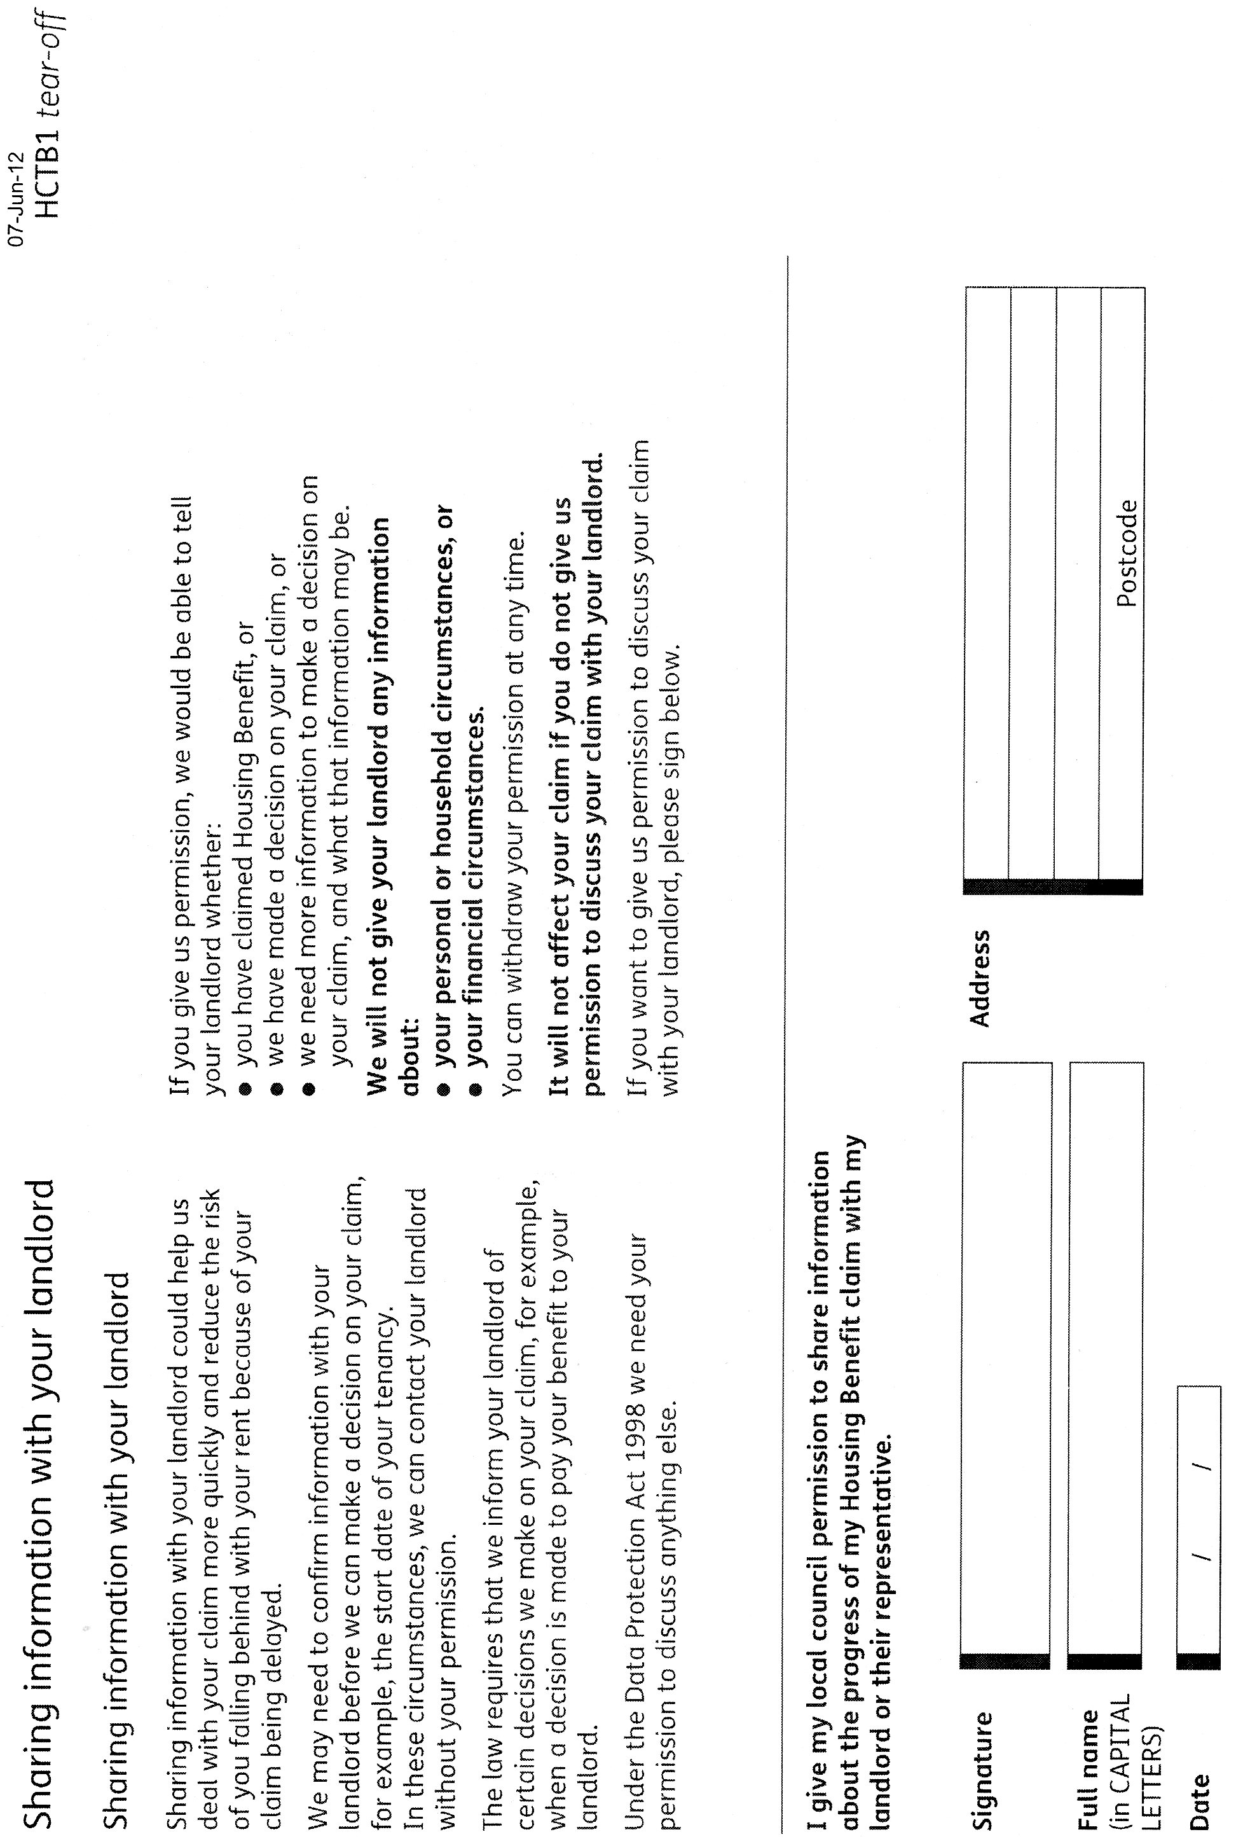

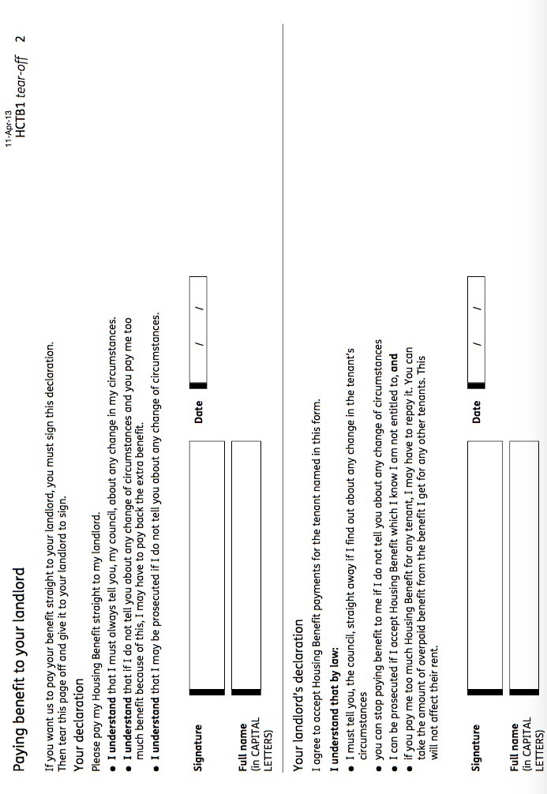
ACKNOWLEDGEMENT FORM
Property Address:
Tenancy Type: | Assured Shorthold
Tenancy Period: | 6 months
Name and address of landlord:
Landlord registration numbers:
By the time your tenancy begins, the landlord must give you the following documents: | - Tenancy agreement  - Gas Safety Certificate (if applicable)  - Tenant Information Pack  - AT5 form

DECLARATION
I can confirm that I have given the tenant all the above documents. I can also confirm that all smoke alarms have been tested to make sure they are working correctly prior to entering this tenancy.
Landlord signature......................................... Date...............................
I can confirm that I have been handed a physical copy of the tenancy agreement and AT5, viewed and taken custody of the tenant’s copy of the Gas Safety Certificate at the main gas appliance and been given the Tenant Information Pack electronically via text (where the text contains a link to the and confirmed receipt of the Tenant Information Pack electronically by sending a text back.
Tenant signature......................................... Date...............................

